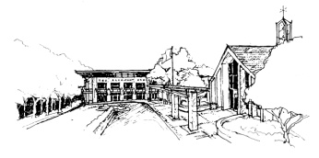
Altamont Alumni Association
September 29, 2020, 5:30pm
via Zoom
(Please keep yourself muted. If you have questions or comments, please use the chat or “raise your hand” function. If a vote is required, please use the chat function to type “aye” or “nay”.)

President: Donald Robinson ‘98
Vice President: Claudia Carcelen ‘07
Treasurer: Scooter Thomas ‘08
Secretary: Jack Gray ‘03

Call to Order & Opening Remarks Donald Robinson

Approval of May Meeting Minutes Jack Gray

Head of School Report Chris Durst

Alumni Town Hall & Further Discussion Various Alumni
Association members in attendance: Jeanne Classe, Scooter Thomas, Donald Robinson,
Chris Nicholson, Lawrence Perry, Stephen Kelly, Terry Hamilton

Financial Report Scooter Thomas
$8,686.62 Balance
(This is the same balance reported at the May 8, 2020 meeting. No activity.)

Alumni Association Going Forward Donald Robinson

Please help spread the word about our first virtual Open House for prospective families!
October 18 from 2-3:30pm

Alumni Board meeting dates for 2020-21 (all meetings at 5:30pm)
Sept. 29, virtual
Nov. 17, virtual
Jan. 19
Mar. 16
May 18

